Cottonwood Hummingbirds.

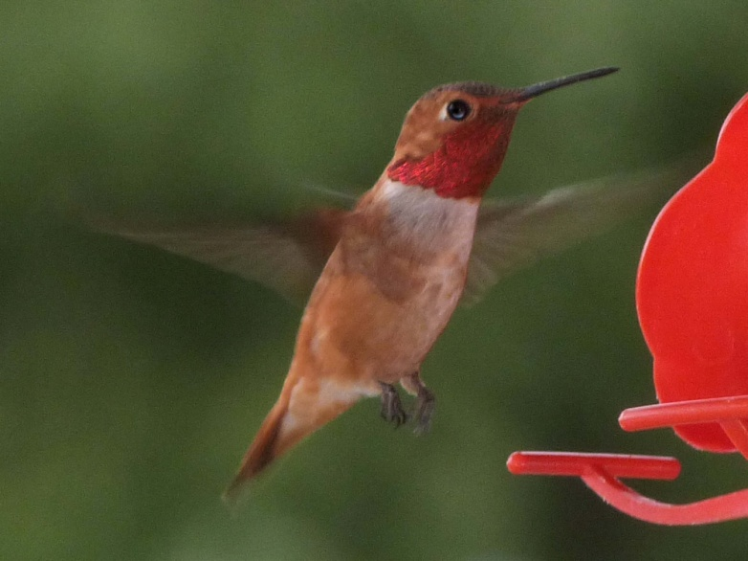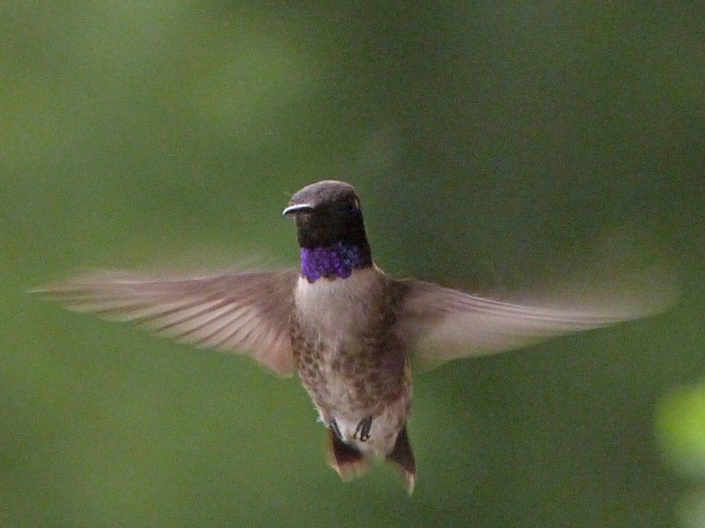
Rufous Hummingbird Black-chinned Hummingbird

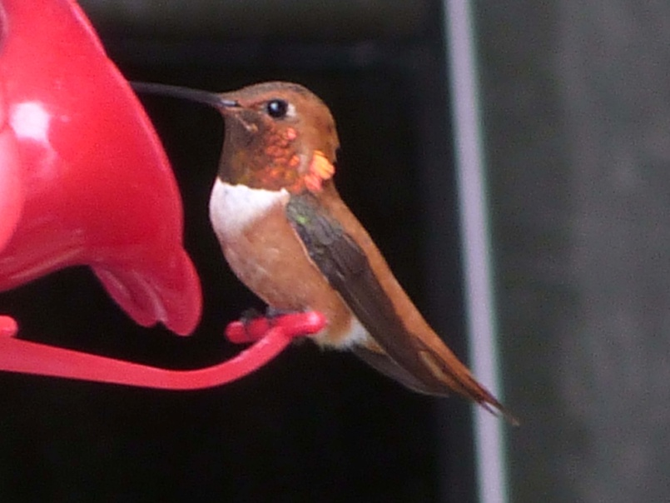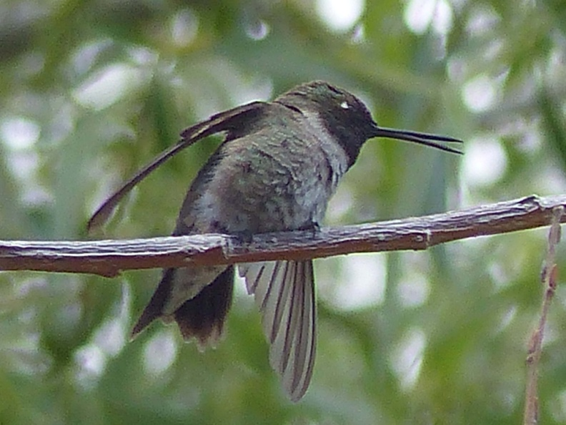
Rufous Hummingbird Black-chinned Hummingbird

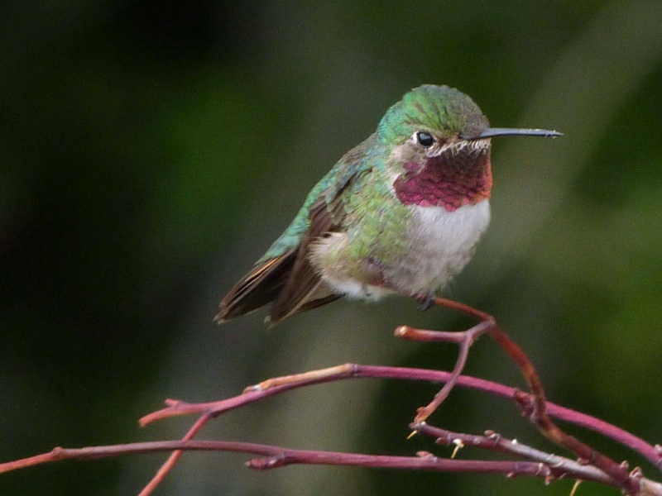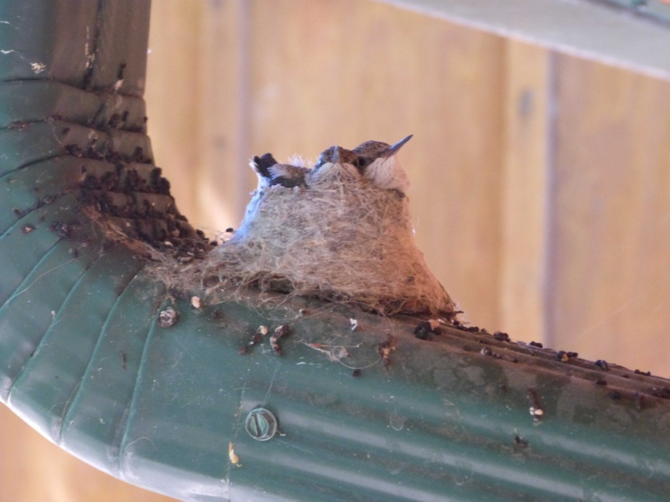
Broad-tailed Hummingbird Black-chinned Hummingbird

